PowerBI and DAX:
--

PowerQuery Editor - Home Ribbon:
Close – Close and Apply
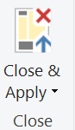

New Query - New Dource, Recent Source, Enter Data
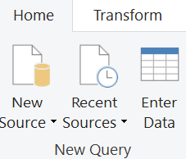

Data Sources – Data source settings;; Parameters – Manage Parameters:
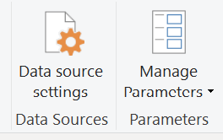
Query – Refresh Preview; Properties; Advanced Editor; Manage(query) - (Delete /Duplicate/Reference):
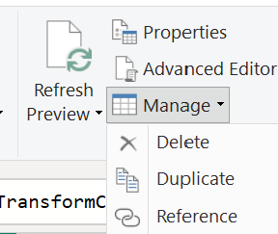
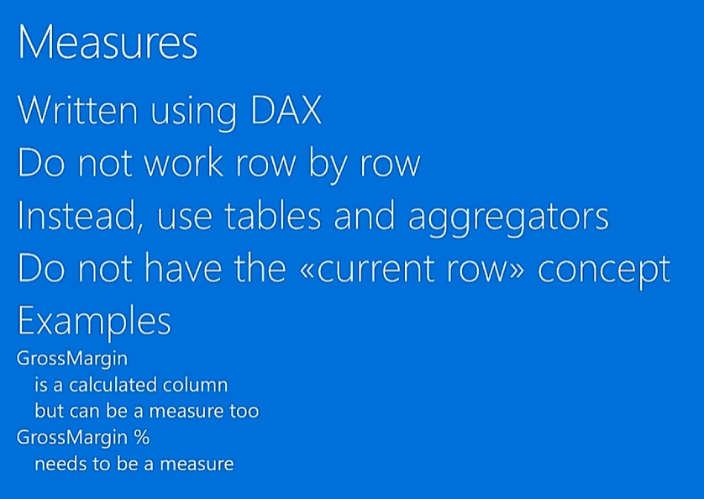

--
New Column (calculated column) :
GrossMargin = Sales[Net Price] – Sles[Unit Cost]
calculated column/ new column computed row by row. Not report specific.
But Measures report specific (i.e if report is group by year/category).
Calculated column (new column) computed at refresh time and stored in model.

New Measure : not row by row, it is report specific calculation.
Below error in measure because it can not determine in report , the measure is report specific , not row by row:
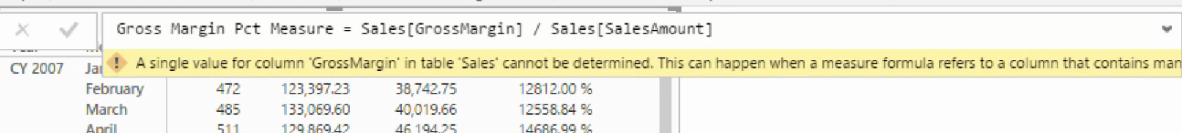

Simply, measures does not have row context, either use aggregate function, or iterator function to apply row context, the iterator run row-by-row.
And,
- So Power BI doesn’t display raw rows — it displays aggregated results per unique combination of selected fields.
🧩 4️⃣ Automatic Aggregation Behavior
Power BI follows these rules:
- If you drag a numeric column, it defaults to SUM (aggregated).
- If you drag a text column, it defaults to Group by.
- If you drag a measure, it’s already aggregated.
--

Gross Margin Pct Measure = SUM( Sales[GrossMargin]) / SUM(Sales[SalesAmount])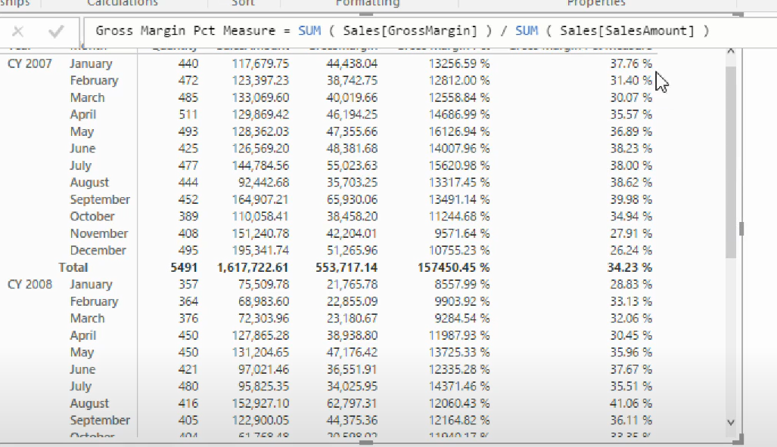

Measures not store in the model, just source code of the model stored in the model.
Its calculated in the report.
There is no Current-Row concept in measure.

--
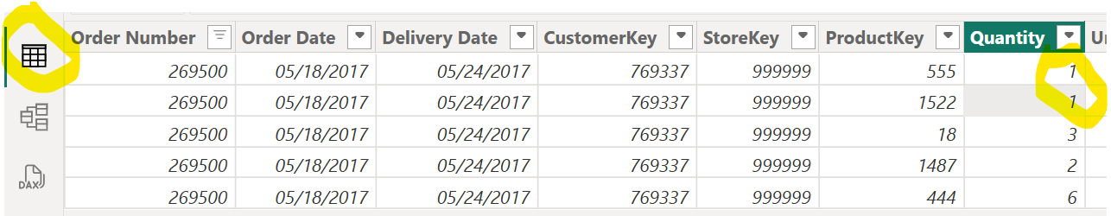
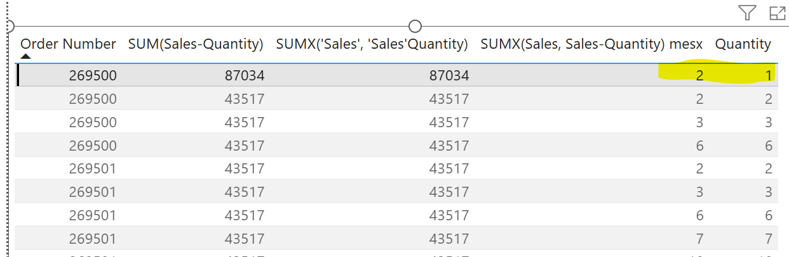
See there is no difference b/w first 2 calculated columns, both are row-by-row, i.e. on row-context in model the value is 43517. In report, since order-number and quantity aggregated , multiple rows for the same [order-no, Quantity] combination the value is summarized.

Since Quantity Summarization property is “Don’t summarize” (by default) it is not summarized.
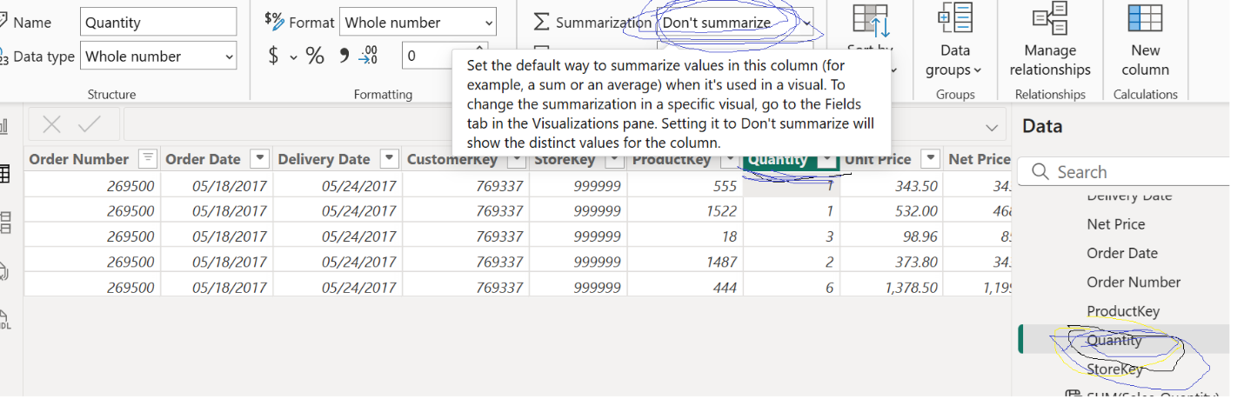
However, the measure column sum values (sum of quantity) correctly, since sumx is an iterator row-by-row. Sum-measure also summarize the quantity correctly :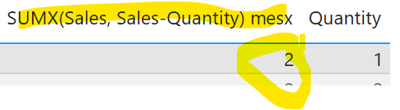
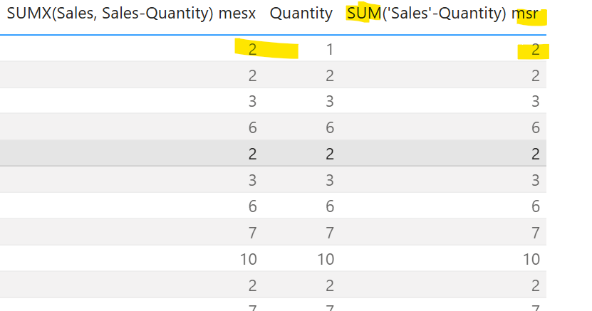

Even quantity column is not selected, both sum and sumx measures calculate correctly.
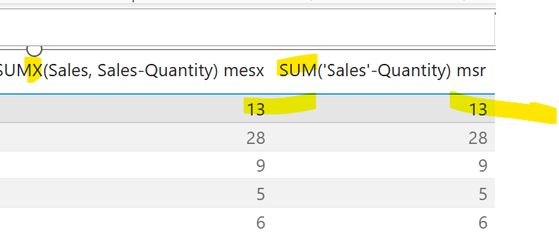
And, can create calculated column in report-view, however, its reflected in model, and its actually belongs to model, and the values stored in model.

---
Simple, calculated columns are behaving like ordinary column since this is created and the values physically stored in model itself.
---
Could NOT create measure with table fields : 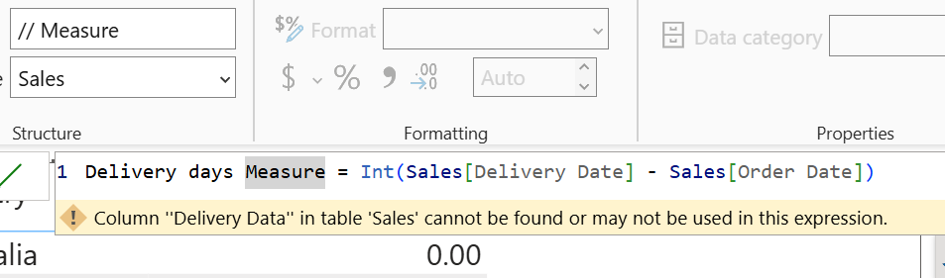
Because those are not determined because those single column have multiple value for current aggregation, so SUM/MAX like aggregate function should be used. So this is not because of table field not access, because of the current filter (or aggregation):
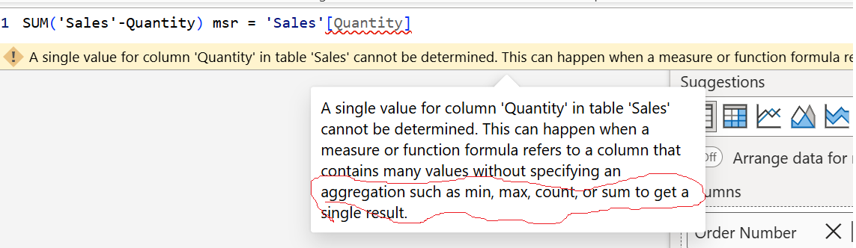

Avg Delivery days Measure =
AVERAGEX(
FILTER('Sales',
RELATED(Store[name])="Online Store")
,INT('Sales'[Delivery Date] - 'Sales'[Order Date])//Sales[Delivery days]
);
CALCULATE(
AVERAGEX(
'Sales',
'Sales'[Delivery Date] - 'Sales'[Order Date] ),
'Store'[Name] = "Online Store" )
Blue Revenue =
CALCULATE(
SUM(Sales[Sales Amount]),
'Product'[Color] = "Blue"
)

- When filter expressions are provided, the CALCULATE function modifies the filter context to evaluate the expression. For each filter expression, there are two possible standard outcomes when the filter expression is not wrapped in the KEEPFILTERS function:
  - If the columns (or tables) aren't in the filter context, then new filters will be added to the filter context to evaluate the expression.
  - If the columns (or tables) are already in the filter context, the existing filters will be overwritten by the new filters to evaluate the CALCULATE expression.
- The CALCULATE function used without filters achieves a specific requirement. It transitions row context to filter context. It's required when an expression (not a model measure) that summarizes model data needs to be evaluated in row context. This scenario can happen in a calculated column formula or when an expression in an iterator function is evaluated. Note that when a model measure is used in row context, context transition is automatic.
- This function is not supported for use in DirectQuery mode when used in calculated columns or row-level security (RLS) rules.

Whereas CALCULATE filters replace the current context, KEEPFILTERS adds filters to the current context, so current context will not be ignored.
But CALCUALTE replace current filter context for specified column which is added in the calculate filter, all other columns filter in the current context wont affect.

Red Sales = CALCULATE( [Sales],
KEEPFILTERS('Product'[Color] = "Red"))
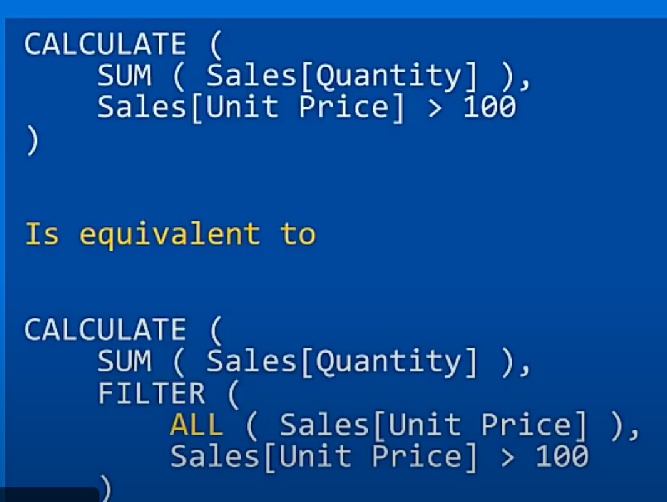

IMPORTANT : while current filter context is respected the subset is feed to the function. While current filter context is not respected( or ignored) by the filter in function then subset not given to the function.
So, CALCULATE function with FILTER and without ALL will obey the current filter context.

Here, the current context filter for product[color] has been ignored.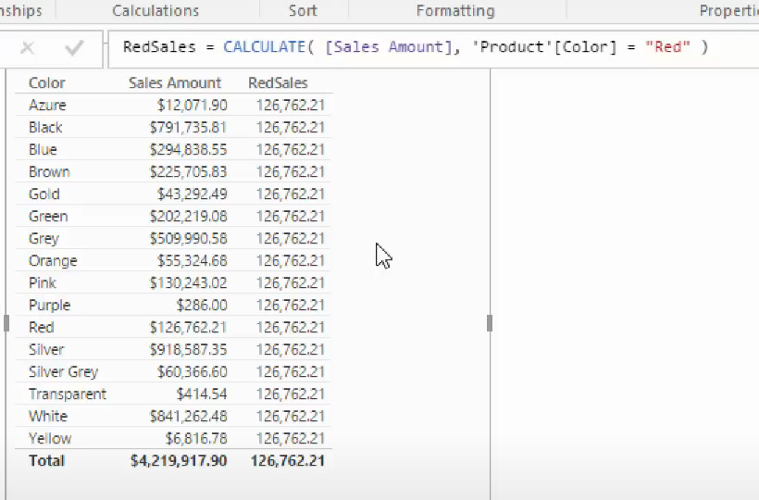
This expression is just a shortcut for the below expression :
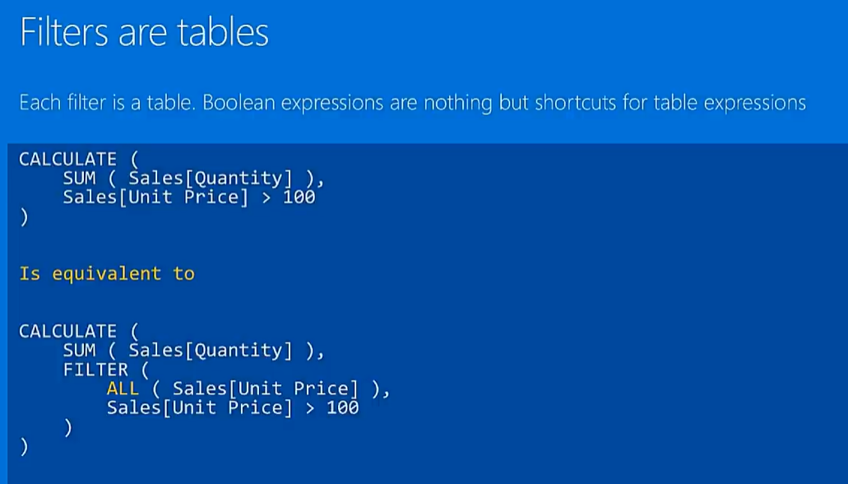
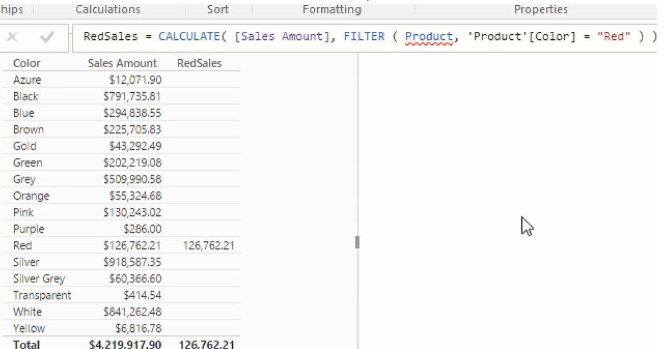

ALL() – function ignores the current filter context.
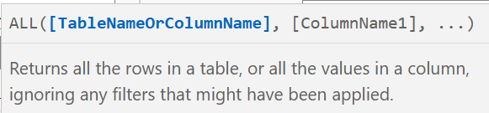
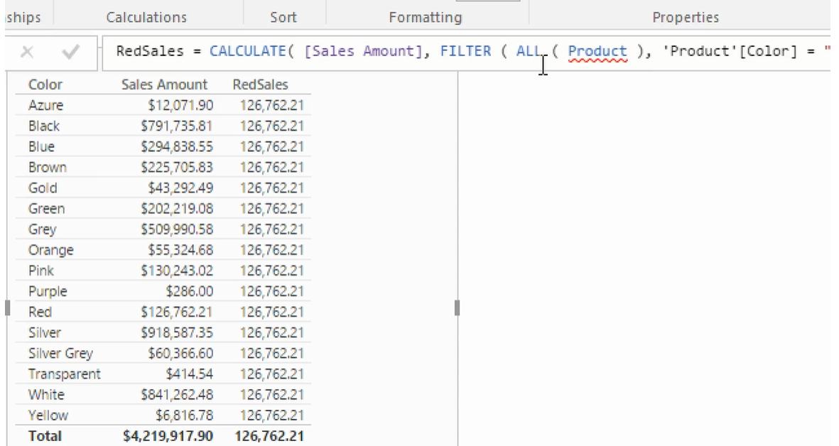
This is equal to CALCULATE([Sales Amount], ‘Product’[color]=”Red”)
-
- ROW CONTEXT – no propagation to related table, so explicitly need to call RELATED/RELATED TABLE.
RELATED –
RELATEDTABLE –

- FILTER CONTEXT – Automatically propagate relation one-to-many, have option to set both instead of single:
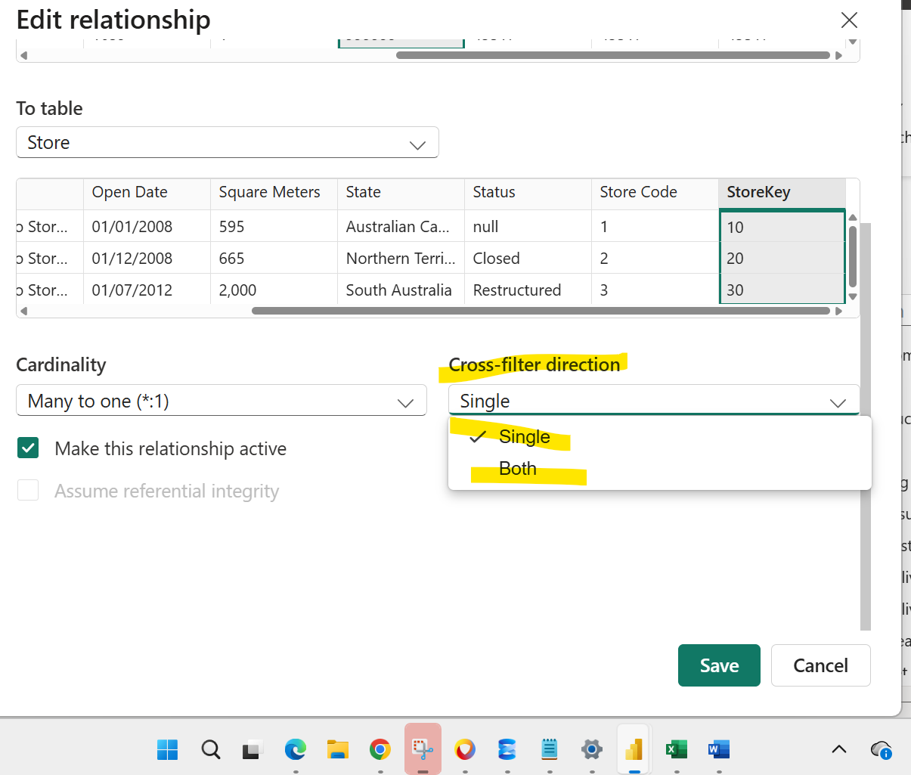

Context Transition :

- A simple aggregation like SUM('Sales'[SalesAmount]) does not inherently know what filters have been applied.
- The automatic CALCULATE wrapper enables context transition, which converts the row context of the visual's filters into a filter context for the measure's calculation.
It handles expressions within iterators:
- When a measure contains an iterator function (like SUMX or AVERAGEX) that in turn references another measure, the implicit CALCULATE wrapper around the inner measure performs context transition. This prevents you from having to manually add a CALCULATE in these nested scenarios.

The contrast highlights the purpose of the wrapper:
- Calculated Column: Evaluated row-by-row, so it already has a row context. It does not need the implicit CALCULATE to force context transition.
- Measure: Evaluated within a filter context, not row-by-row. The CALCULATE wrapper is what gives it this capability.

--
1. Calculated column SUM , SUMX
2. Calculated column – CALCULATE – SUM,SUMX
3.Measure SUM, SUMX
4. Measure – CALCULATE – SUM, SUMX

--
Total Value =
SUMX(
Sales,
Sales[Quantity] *
RELATED(Product[Cost]) *
(1 + RELATED(Tax[TaxRate]))
)
--
Sum of Product =
SUMX(
SUMMARIZE(
Sales,
Sales[ProductID],
"Qty", SUM(Sales[Quantity]),
"Cost", RELATED(Product[Cost]),
"Tax", RELATED(Tax[TaxRate])
),
[Qty] * [Cost] * (1 + [Tax])
)

SUMMARIZE (<table>, <groupBy_columnName>[, <groupBy_columnName>]…[, <name>, <expression>]…)
Term | Definition
table | Any DAX expression that returns a table of data.
groupBy_ColumnName | (Optional) The qualified name of an existing column used to create summary groups based on the values found in it. This parameter cannot be an expression.
name | The name given to a total or summarize column, enclosed in double quotes.
expression | Any DAX expression that returns a single scalar value, where the expression is to be evaluated multiple times (for each row/context).

In Power BI's Data Analysis Expressions (DAX), an automatic CALCULATE function wrapper is implicitly applied when a measure is used within a row context, a process known as context transition. This behavior is key to creating flexible and dynamic calculations in your data model.
How automatic CALCULATE and context transition work
Context transition is the automatic conversion of a row context into a filter context. This is essential for calculating an aggregated measure on a row-by-row basis.
- Row context: In a row context, a DAX expression is evaluated for each individual row of a table. This occurs in calculated columns and in iterator functions like SUMX, AVERAGEX, or MAXX.
- Filter context: In a filter context, a DAX expression is evaluated based on the filters applied by visuals in your report (e.g., a slicer, a bar chart, etc.).
- The transition: When you place a measure inside an iterator function, DAX automatically wraps the measure in an invisible CALCULATE function. This CALCULATE function captures the current row's values from the row context and applies them as filters to the measure's calculation, effectively transitioning the row context into a filter context.
Example: Measure vs. Calculated Column
The difference between a calculated column and a measure illustrates how context transition works.
Calculated Column approach
If you create a calculated column to compute Line Amount by multiplying [Quantity] and [Net Price], no aggregation is needed. The expression [Quantity] * [Net Price] is evaluated row by row.
dax
Line Amount = Sales[Quantity] * Sales[Net Price]
This is an efficient approach if you need to slice and dice on the result, but it increases the size of your data model and is less memory-efficient than a measure.
Measure approach with automatic CALCULATE
A more memory-efficient method is to create a measure that performs the same calculation, as measures are evaluated on the fly. However, you cannot simply write SUMX(Sales, Sales[Quantity] * Sales[Net Price]) and expect the same result when referencing a measure inside the iterator.
Consider a simple [Total Sales] measure:
dax
Total Sales = SUM(Sales[Line Amount])
Now, let's create a measure that calculates the average sales per customer, using the [Total Sales] measure. The following DAX demonstrates how the automatic CALCULATE comes into play:
dax
Average Sales Per Customer = AVERAGEX(Customers, [Total Sales])
- The AVERAGEX function iterates through each row of the Customers table. This creates a row context.
- For each customer row, the AVERAGEX function needs the total sales for that specific customer. It calls the [Total Sales] measure.
- Since the [Total Sales] measure is being evaluated within a row context, DAX automatically wraps it in CALCULATE.
- The invisible CALCULATE function takes the customer ID from the current row context and applies it as a filter to the [Total Sales] measure.
- The measure is then evaluated under this new filter context, returning the Total Sales for that single customer.
- AVERAGEX then averages these calculated totals across all customers.
This automatic wrapping eliminates the need to manually write the CALCULATE function inside the iterator, keeping your code cleaner and easier to read.
-
RELATED
- What it does: Returns a single value (a scalar value) from a related table.
- When to use it: When you are in a row context of a "many" side table and need to look up a value from the "one" side table.
- Example: In a Sales table (the "many" side), you can create a calculated column to get the EnglishProductName from a related Products table (the "one" side) using RELATED(Products[EnglishProductName]).
RELATEDTABLE
- What it does:
Returns a table containing all rows from the related table that are connected to the current row.
- When to use it:
When you need to perform operations on the entire set of related rows on the "many" side of a relationship from the perspective of the "one" side.
- Example:
In a Products table (the "one" side), you could use RELATEDTABLE(Sales) inside an iterator function like SUMX to calculate the total sales for that product. For instance, SUMX(RELATEDTABLE(Sales), Sales[Quantity] * Sales[NetPrice]) would sum up the sales for each product.
-
LOOKUPVALUE (
<result_columnName>,
<search_columnName>,
<search_value>
[, <search2_columnName>, <search2_value>]…
[, <alternateResult>]
)
If there is a relationship between the table that contains the result column and tables that contain the search columns, in most cases, using the RELATED function instead of LOOKUPVALUE is more efficient and provides better performance.
--
Models :
A database model is the logical structure that defines how data is stored, organized, and related within a database. It acts as a blueprint, specifying rules, relationships, and constraints to ensure data integrity and efficient access. The most common type is the relational model, which organizes data into tables with rows and columns, but other models like NoSQL, dimensional, and hierarchical models also exist.
Just db architecture (diagram).
Ex : ER-Diagram.
---
Columnar Database :
A columnar database stores data by column rather than by row, grouping all values for a specific attribute(column) together, which significantly speeds up analytical queries (OLAP) and data warehousing by reducing disk I/O and improving compression, ideal for big data analytics where you often need aggregate functions on large datasets, unlike traditional row-based databases (OLTP) that excel at transaction processing.

Since aggregation on a single column is often need , all attribute value can read in single place is very quick rather than read each value from each row.

In a Columnar DBMS, the data stored is in this format (as one string):
534782, 585523, 479148; Miller, Parker, Stacy; Ginny, Peter, Gwen; 6000, 8000, 2000.
In RDBMS :
534782, Miller, Ginny, 6000; 585523, Parker, Peter, 8000; 479148, Stacy, Gwen, 2000.

Columnstore indexes in Microsoft SQL Server : (a columnar approach) :
Columnstore indexes in Microsoft SQL Server are a type of index designed to significantly improve performance for analytical workloads, particularly in data warehousing scenarios. Unlike traditional row-oriented indexes (like clustered and non-clustered indexes) that store data row by row, columnstore indexes store data in a column-wise format.
- Types of Columnstore Indexes:
  - Clustered Columnstore Index (CCI): This is the primary storage for the entire table. When a CCI is created, the base table is transformed into a columnstore format.
  - Nonclustered Columnstore Index (NCCI): This is a secondary index created on a traditional row-oriented (heap or clustered index) table. It provides the benefits of columnstore technology for analytical queries while the base table remains in a row-oriented format, suitable for transactional workloads.
CREATE [ NONCLUSTERED ] COLUMNSTORE INDEX
--

